Banoth Sowjanya

**CREATION OF SINGLE PAGE WEBSITE**

**PROJECT 1 - CREATION OF SINGLE PAGE WEBSITE**

**Task : Create a Single Page Portfolio Website**

**ABSTRACT :**

This project embarks on the creation of a single-page website meticulously designed to serve as an educational gateway into the vast realm of web development. By harnessing the power of fundamental technologies like HTML, CSS, and JavaScript, this endeavor endeavors to offer a hands-on learning experience. The website is meticulously crafted to cater primarily to beginners seeking to delve into the intricacies of web development, presenting a seamless blend of interactive content and informative sections.

At its core, the website aims to provide an intuitive platform where budding enthusiasts can traverse through the diverse facets of web development with ease. Through meticulously curated content and engaging tutorials, users are encouraged to embark on a journey of exploration, unraveling the mysteries of both frontend and backend technologies. From the rudimentary foundations of HTML and CSS to the dynamic functionalities of JavaScript, the website offers a comprehensive learning experience tailored to accommodate varying levels of proficiency.

By amalgamating theoretical knowledge with practical application, the website seeks to empower learners to not only comprehend but also actively engage with the intricacies of web development. Through interactive elements and immersive experiences, users are afforded the opportunity to apply acquired knowledge in real-time scenarios, fostering a deeper understanding of the subject matter. Ultimately, the overarching goal of this single-page website is to instill confidence and competence in beginners, equipping them with the necessary skills to navigate the dynamic landscape of web development with proficiency and finesse.

**OBJECTIVES :**

**Educational Platform :** Create a user-friendly website that serves as an educational platform for individuals interested in learning web development. Interactive Content: Provide interactive content such as tutorials, guides, and examples to engage users and enhance learning.

**Comprehensive Coverage :** Cover various topics in web development, including HTML, CSS, JavaScript, frontend frameworks, backend technologies, and best practices.

**Responsive Design :** Ensure that the website is accessible across different devices and screen sizes, maintaining a responsive design.

**Engagement and Feedback** : Implement features to encourage user engagement, such as contact forms for inquiries and feedback, and social media integration for community interaction.

**Progress Tracking :** Implement functionality to track user progress through interactive quizzes, exercises, or checkpoints, allowing learners to monitor their advancement and identify areas for improvement.

**Accessibility Features :** Integrate accessibility features such as screen reader compatibility, keyboard navigation support, and adjustable font sizes to ensure inclusivity and accommodate users with diverse needs.

**Multimedia Integration :** Incorporate multimedia elements such as videos, infographics, and interactive coding environments to cater to different learning styles and enhance content comprehension.

**Community Collaboration :** Foster a sense of community among learners by facilitating collaboration through discussion forums, peer-to-peer mentoring platforms, or group projects, encouraging knowledge sharing and networking opportunities.

**Career Resources :** Provide resources and guidance on career paths in web development, including job search tips, resume building workshops, and portfolio development assistance, to empower learners in their professional endeavors.

**Gamification Elements :** Introduce gamification elements such as badges, rewards, and leaderboards to incentivize learning, increase motivation, and foster a sense of achievement among users as they progress through the educational journey.

**Data Analytics and Insights** : Utilize data analytics tools to gather insights into user behavior, preferences, and learning patterns, enabling continuous optimization of the website's content, features, and user experience based on empirical data-driven decisions.

**INTRODUCTION :**

The project aims to address the growing demand for accessible resources in web development education. With the increasing importance of digital literacy and online presence, learning web development has become a valuable skill. However, many beginners find it challenging to navigate through the vast amount of information available online. This website seeks to provide a structured learning environment where users can progress at their own pace and access curated resources tailored to their needs.

In today's digital age, the significance of web development education has surged, paralleling the exponential growth of the online realm. As businesses, individuals, and organizations alike strive to establish their digital footprint, proficiency in web development has evolved into an indispensable skill. However, amidst the abundance of information available online, aspiring developers often find themselves overwhelmed and directionless, struggling to navigate the labyrinth of resources scattered across the internet.

Recognizing this pervasive challenge, our project endeavors to fill a crucial void in the educational landscape by offering a structured and accessible platform for learning web development. By amalgamating cutting-edge technologies with pedagogical expertise, we aspire to democratize access to high-quality educational resources, irrespective of one's prior experience or background in programming. Our website serves as a beacon of guidance and support, empowering learners to embark on their journey into the dynamic world of web development with confidence and clarity.

At the heart of our initiative lies a commitment to fostering a culture of continuous learning and growth, where users can embark on a transformative educational odyssey tailored to their unique aspirations and learning styles. Whether delving into the intricacies of HTML and CSS, exploring the nuances of JavaScript frameworks, or unraveling the complexities of backend technologies, our comprehensive curriculum caters to learners at every stage of their development journey. Through a meticulously curated repository of tutorials, interactive exercises, and real-world examples, we endeavor to instill not only technical proficiency but also a deep-seated passion for innovation and creativity in our users.

**METHODOLOGY :**

**Content Curation :**  Gather relevant educational resources, including tutorials, articles, videos, and interactive exercises, covering various topics in web development.

**Design and Development :**  Utilize HTML, CSS, and JavaScript to design and develop the user interface and interactive elements of the website. Employ responsive design principles to ensure compatibility across devices.

**Integration of Resources :** Organize and integrate curated content into the website, categorizing topics and providing navigation aids for easy access.

**Testing and Feedback :** Conduct thorough testing across different browsers and devices to identify and address any compatibility issues. Gather feedback from users to iterate and improve the user experience.

**Deployment :** Deploy the website to a hosting platform to make it accessible to users worldwide.

**CODE :**

<!DOCTYPE html>

<html lang="en"><head><meta charset="utf-8">

      <head>

        <meta name="description" content="My first website used for learning">

        <meta name="keyword" content="HTML,CSS,Javascript, learning, New learning,Studentys">

        <meta name="author" content="BANOTH SOWJANYA">

        <meta name="viewport" content="width=device-width, initial-scale=1">

        <title>Single Page Website | Minor Project </title>

        <link href="https://cdn.jsdelivr.net/npm/bootstrap@5.3.3/dist/css/bootstrap.min.css" rel="stylesheet" integrity="sha384-QWTKZyjpPEjISv5WaRU9OFeRpok6YctnYmDr5pNlyT2bRjXh0JMhjY6hW+ALEwIH" crossorigin="anonymous">

        <link rel="stylesheet" href="https://cdn.jsdelivr.net/npm/@fortawesome/fontawesome-free@6.2.1/css/fontawesome.min.css" integrity="sha384-QYIZto+st3yW+o8+5OHfT6S482Zsvz2WfOzpFSXMF9zqeLcFV0/wlZpMtyFcZALm" crossorigin="anonymous">

        <link rel="stylesheet" href="https://cdn.jsdelivr.net/npm/bootstrap-icons@1.10.2/font/bootstrap-icons.css" integrity="sha384-b6lVK+yci+bfDmaY1u0zE8YYJt0TZxLEAFyYSLHId4xoVvsrQu3INevFKo+Xir8e" crossorigin="anonymous">

        <style>

         .services-display{

            margin-top: 15px;

            margin-bottom: 15px;

            font-size: 35px;

            font-weight: 200;

         }

         .flip-card-body{

            position: relative;

            transition: transform 0.9s;

            transform-style: preserve-3d;

         }

         .my-card:hover .flip-card-body {

            transform: rotateY(180deg);

         }

         .card-back{

            transform: rotateY(180deg);

         }

         .card-front, .card-back{

            position: absolute;

            backface-visibility: hidden;

         }

        </style>

     </head>

     <body>

       <nav class="navbar navbar-expand-lg navbar-light bg-light">

            <div class="container-fluid">

                  <a class="navbar-brand" href="file:///C:/Users/rajit/OneDrive/Desktop/FRONTEND_MINOR_PROJECT/index.html">

                     <img src="https://th.bing.com/th/id/OIP.xd730R2aWaRMmTCeNyA-fAAAAA?w=256&h=256&rs=1&pid=ImgDetMain" height="70" alt="Brand Logo">

                  </a>

                  <div class="collapse navbar-collapse" id="navbarlinkcontainer">

                     <ul class="navbar-nav me-auto mb-2 mb-lg-0">

                        <li class="nav-item">

                           <a class="nav-link active" href="C:\Users\rajit\OneDrive\Desktop\FRONTEND_MINOR_PROJECT\Single Page Website _ Minor Project.html">Home</a>

                        </li>

                        <li class="nav-item">

                           <a class="nav-link" href="C:\Users\rajit\OneDrive\Desktop\FRONTEND_MINOR_PROJECT\Single Page Website _ Minor Project.html">About</a>

                        </li>

                        <li class="nav-item">

                           <a class="nav-link" href="C:\Users\rajit\OneDrive\Desktop\FRONTEND_MINOR_PROJECT\Single Page Website _ Minor Project.html">Contact Us</a>

                        </li>

                     </ul>

                  </div>

                  <button class="navbar-toggler" type="button" data-bs-toggle="collapse" data-bs-target="#navbar">

                     <span class="navbar-toggler-icon"></span>

                  </button>

               </div>

            </nav>

            <div id="myCarousel" class="carousel slide" data-bs-ride="carousel">

               <div class="carousel-indicators">

                  <button type="button" data-bs-target="#myCarousel" class="active" data-bs-slide-to="0"></button>

                  <button type="button" data-bs-target="#myCarousel" data-bs-slide-to="1"></button>

                  <button type="button" data-bs-target="#myCarousel" data-bs-slide-to="2"></button>

               </div>

               <div class="carousel-inner">

                  <div class="carousel-item active">

                     <img src="https://wallpaperaccess.com/full/3239444.jpg" class="d-block  w-100" alt="carousel 1">

                  </div>

                  <div class="carousel-item">

                     <img src="./Single Page Website _ Minor Project_files/fff" class="d-block  w-100" alt="carousel 2">

                  </div>

                  <div class="carousel-item">

                     <img src="./Single Page Website _ Minor Project_files/fff" class="d-block  w-100" alt="carousel 3">

                  </div>

               </div>

               <button class="carousel-control-prev" type="button" data-bs-target="#myCarousel" data-bs-slide="prev">

                  <span class="carousel-control-prev-icon"></span>

               </button>

               <button class="carousel-control-prev" type="button" data-bs-target="#myCarousel" data-bs-slide="next">

                  <span class="carousel-control-prev-icon"></span>

               </button>

            </div>

            <div class="container-fluid mt-4">

               <h5 class="display-4 text-center">About Us</h5>

               <div class="row mt-4">

                  <div class="col-6">

                     <img src="https://i.pinimg.com/originals/ba/0e/b8/ba0eb82dbe74fb21925083c2ea7475b4.jpg" class="d-block  w-100" height="350" alt="About Us">

                  </div>

                  <div class="col-6">

                     <p>Web development is a dynamic field that involves the creation, building, and maintenance of websites and web applications. It’s a discipline that combines creativity with technical skills to produce interactive, user-friendly digital experiences. At its core, web development encompasses web design, web content development, client-side/server-side scripting, and network security configuration.</p>

                     <p>The process of web development is divided into two main areas: front-end and back-end development. Front-end development focuses on the aspects of a website that users interact with directly. It involves the use of languages like HTML, CSS, and JavaScript to create the layout, design, and interactivity of a website. Back-end development, on the other hand, deals with the server-side of the application. It’s responsible for managing database interactions, user authentication, and server logic.</p>

                  </div>

               </div>

            </div>

            <div class="container-fluid mt-4">

               <h5 class="display-4 text-center">Our Services</h5>

               <div class="row mt-4">

                  <div class="col-4 text-center">

                     <div class="display-4">

                        <i class="bi bi-globe-americas"></i>

                     </div>

                     <p class="services-display">Global Services</p>

                  </div>

                  <div class="col-4 text-center">

                     <div class="display-4">

                        <i class="bi bi-people"></i>

                     </div>

                     <p class="services-display">Manpower Services</p>

                  </div>

                  <div class="col-4 text-center">

                     <div class="display-4">

                        <i class="bi bi-boxes"></i>

                     </div>

                  </div>

                  <p class="services-display">Logistics Services</p>

               </div>

            </div>

            <div class="row mt-4">

               <div class="col-4 text-center">

                  <div class="display-4">

                     <i class="bi bi-airplane"></i>

                  </div>

                  <p class="services-display">Travel Services</p>

               </div>

               <div class="col-4 text-center">

                  <div class="display-4">

                     <i class="bi bi-person-video3"></i>

                  </div>

                  <p class="services-display">Consultation Services</p>

               </div>

               <div class="col-4 text-center">

                  <div class="display-4">

                     <i class="bi bi-journal-richtext"></i>

                  </div>

                  <p class="services-display">E learning Services</p>

               </div>

            </div>

         </div>

         <div class="container-fluid mt-4">

            <h5 class="display-4 text-center">Our Team</h5>

            <div class="d-flex justify-content-center">

               <div class="row mt-4">

                  <div class="col-4">

                     <div class="card" style="width: 300px;">

                        <div class="card-img-top">

                           <img src="https://th.bing.com/th/id/OIP.araMPKa_fS5UkVD3OyEznAAAAA?rs=1&pid=ImgDetMain" class="d-block w-100" alt="slide 3">

                        </div>

                        <div class="card-body">

                           <div class="card-title text-center">

                              <h5>BANOTH SOWJANYA</h5>

                              <p>Game Developer</p>

                              <p>The game developer spent countless hours debugging the code to ensure a smooth gameplay experience for users.</p>

                           </div>

                           <div class="card-title text-center" style="font-size: 25px;">

                              <a href="https://linkedin.com/"><i class="bi bi-linkedin me-2"></i></a>

                              <i class="bi bi-facebook me-2"></i>

                              <i class="bi bi-envelope-at-fill me-2"></i>

                              <i class="bi bi-twitter-x me-2"></i>

                           </div>

                        </div>

                     </div>

                  </div>

                  <div class="col-4">

                     <div class="card my-card" style="width:300px;">

                        <div class="flip-card-body">

                           <div class="card-front">

                              <div class="card-img-top">

                                 <img src="https://th.bing.com/th/id/OIP.ahuSbrwmn7yvxXeF7K3ZdgHaE8?rs=1&pid=ImgDetMain" class="d-block w-100" alt="slide 3">

                           </div>

                           <div class="card-body">

                              <div class="card-title text-center">

                                 <h5>BANOTH SANJU</h5>

                                 <p>Web Developer</p>

                                 <p>As a web developer, she specializes in creating responsive designs that provide an optimal viewing experience across a wide range of devices.</p>

                              </div>

                              <div class="card-title text-center" style="font-size: 25px;">

                                 <a href="https://linkedin.com/"><i class="bi bi-linkedin me-2"></i></a>

                                 <i class="bi bi-facebook me-2"></i>

                                 <i class="bi bi-envelope-at-fill me-2"></i>

                                 <i class="bi bi-twitter-x me-2"></i>

                              </div>

                           </div>

                        </div>

                        <div class="card-back">

                           do something

                        </div>

                     </div>

                  </div>

               </div>

               <div class="col-4">

                  <div class="card" style="width: 300px;">

                     <div class="card-img-top">

                        <img src="https://th.bing.com/th/id/OIP.t3AeRbnlAKmcn2lqzGfKuwHaE8?rs=1&pid=ImgDetMain" class="d-block w-100" alt="slide 3">

                           </div>

                           <div class="card-body">

                              <div class="card-title text-center">

                                 <h5>BANOTH AMMU</h5>

                                 <p>Skilled Developer</p>

                                 <p>A skilled developer can write clean, efficient code that powers applications and solves complex problems.</p>

                              </div>

                              <div class="card-title text-center" style="font-size: 25px;">

                                 <a href="https://linkedin.com/"><i class="bi bi-linkedin me-2"></i></a>

                                 <a href="https://facebook.com/"></a><i class="bi bi-facebook me-2"></i></a>

                                 <a href="https://mail.google.com/"></a><i class="bi bi-envelope-at-fill me-2"></i></a>

                                 <a href="https://linkedin.com/"></a><i class="bi bi-twitter-x me-2"></i></a>

                              </div>

                           </div>

                     </div>

                  </div>

               </div>

            </div>

         </div>

         <div class="mt-4">

            <h5 class="display-4 text-center">Contact Us</h5>

              <div class="row mt-4">

                 <div class="col-6">

                   <div class="container p-3">

                       <p class="text-muted text-center fs-3">Here's our Contact Info</p>

                       <div class="text-black-s text-center fs-4">Our Email</div>

                       <div class="text-black-50 text-center fs-5">eg321@example.com</div>

                       <div class="text-black-s text-center fs-4">Our Phone No.</div>

                       <div class="text-black-50 text-center fs-5">+91 xxxxx xxxxx</div>

                       <div class="text-black-s text-center fs-4">Our Address</div>

                       <div class="text-black-50 text-center fs-5">HSR Layout, Bangalore <br> Karnataka 560 xxx</div>

                   </div>

                 </div>

                 <div class="col-6">

                  <div class="container-fluid">

                     <p class="text-muted text-center fs-3">You can also write to Us</p>

                     <div class="container p-3">

                        <div class="card shadow">

                           <div class="card-body">

                              <form>

                                 <div class="form-group">

                                    <label for="name" class="form-label">Enter Your Name</label>

                                    <input type="text" class="form-control" name="name" id="name">

                                 </div>

                                 <div class="form-group">

                                    <label for="emailid" class="form-label">Enter Your Email</label>

                                    <input type="email" class="form-control" name="email" id="emailid">

                                 </div>

                                 <div class="form-group">

                                    <label for="subject" class="form-label">Enter the Subject</label>

                                    <input type="text" class="form-control" name="subject" id="subject">

                                 </div>

                                 <div class="form-group">

                                    <label for="Message" class="form-label">Enter Your Message</label>

                                    <textarea class="form-control" name="Message" id="Message"></textarea>

                                 </div>

                                 <div class="form-group text-center">

                                    <input type="submit" class="btn btn-outline-dark" value="Send Message">

                                 </div>

                              </form>

                           </div>

                        </div>

                     </div>

                  </div>

               </div>

            </div>

       </div>

         <div class="container">

            <footer class="py-5">

               <div class="row">

                  <div class="col-2">

                     <h5>Sections</h5>

                     <ul class="nav flext-column">

                        <li class="nav-item mb-2">

                           <a href="C:\Users\rajit\OneDrive\Desktop\FRONTEND_MINOR_PROJECT\Single Page Website _ Minor Project.html" class="nav-link p-0 text-muted">Home  </a>

                        </li>

                        <li class="nav-item mb-2">

                           <a href="C:\Users\rajit\OneDrive\Desktop\FRONTEND_MINOR_PROJECT\Single Page Website _ Minor Project.html" class="nav-link p-0 text-muted">About Us  </a>

                        </li>

                        <li class="nav-item mb-2">

                           <a href="C:\Users\rajit\OneDrive\Desktop\FRONTEND_MINOR_PROJECT\Single Page Website _ Minor Project.html" class="nav-link p-0 text-muted">Contact Us</a>

                        </li>

                     </ul>

                  </div>

                  <div class="col-2">

                     <h5>Sections</h5>

                     <ul class="nav flext-column">

                        <li class="nav-item mb-2">

                           <a href="C:\Users\rajit\OneDrive\Desktop\FRONTEND_MINOR_PROJECT\Single Page Website _ Minor Project.html" class="nav-link p-0 text-muted">Home</a>

                        </li>

                        <li class="nav-item mb-2">

                           <a href="C:\Users\rajit\OneDrive\Desktop\FRONTEND_MINOR_PROJECT\Single Page Website _ Minor Project.html" class="nav-link p-0 text-muted">About Us</a>

                        </li>

                        <li class="nav-item mb-2">

                           <a href="C:\Users\rajit\OneDrive\Desktop\FRONTEND_MINOR_PROJECT\Single Page Website _ Minor Project.html" class="nav-link p-0 text-muted">Contact Us</a>

                        </li>

                     </ul>

                  </div>

                  <div class="col-2">

                     <h5>Sections</h5>

                     <ul class="nav flext-column">

                        <li class="nav-item mb-2">

                           <a href="C:\Users\rajit\OneDrive\Desktop\FRONTEND_MINOR_PROJECT\Single Page Website _ Minor Project.html" class="nav-link p-0 text-muted">Home</a>

                        </li>

                        <li class="nav-item mb-2">

                           <a href="C:\Users\rajit\OneDrive\Desktop\FRONTEND_MINOR_PROJECT\Single Page Website _ Minor Project.html" class="nav-link p-0 text-muted">About Us</a>

                        </li>

                        <li class="nav-item mb-2">

                           <a href="C:\Users\rajit\OneDrive\Desktop\FRONTEND_MINOR_PROJECT\Single Page Website _ Minor Project.html" class="nav-link p-0 text-muted">Contact Us</a>

                        </li>

                     </ul>

                  </div>

                  <div class="col-4 offset-1">

                     <h5>Subscribe to our Newsletter</h5>

                     <p>Get News</p>

                     <div class="d-flex w-100 gap-2">

                        <input type="text" class="form-control" placeholder="Enter  your email address">

                        <button class="btn btn-primary ">Subscribe</button>

                     </div>

                  </div>

               </div>

               <div class="d-flex justify-content-between py-4 my-4 border-top">

                  <p>© 2024 student All rights reserved.</p>

                  <ul class="list-unstyled d-flex" style="font-size: 20px;">

                     <li class="ms-3">

                        <a class="link-dark" href="file:///C:/Users/rajit/OneDrive/Desktop/FRONTEND_MINOR_PROJECT/index.html">

                           <i class="bi bi-facebook me-2"></i>

                        </a>

                     </li>

                     <li class="ms-3">

                        <a class="link-dark" href="file:///C:/Users/rajit/OneDrive/Desktop/FRONTEND_MINOR_PROJECT/index.html">

                           <i class="bi bi-envelope-at-fill me-2"></i>

                        </a>

                     </li>

                     <li class="ms-3">

                        <a class="link-dark" href="file:///C:/Users/rajit/OneDrive/Desktop/FRONTEND_MINOR_PROJECT/index.html">

                           <i class="bi bi-twitter-x me-2"></i>

                        </a>

                     </li>

                  </ul>

               </div>

            </footer>

         </div>

         <link href="https://cdn.jsdelivr.net/npm/bootstrap@5.3.3/dist/css/bootstrap.min.css" rel="stylesheet" integrity="sha384-QWTKZyjpPEjISv5WaRU9OFeRpok6YctnYmDr5pNlyT2bRjXh0JMhjY6hW+ALEwIH" crossorigin="anonymous">

         <script src="./Single Page Website _ Minor Project_files/jquery-3.3.1.slim.min.js.download" integrity="sha384-q8i/X+965DzO0rT7abK41JStQIAqVgRVzpbzo5smXKp4YfRvH+8abtTE1Pi6jizo" crossorigin="anonymous"></script>

         <script src="./Single Page Website _ Minor Project_files/popper.min.js.download" integrity="sha384-UO2eT0CpHqdSJQ6hJty5KVphtPhzWj9WO1clHTMGa3JDZwrnQq4sF86dIHNDz0W1" crossorigin="anonymous"></script>

         <script src="./Single Page Website _ Minor Project_files/bootstrap.min.js.download" integrity="sha384-JjSmVgyd0p3pXB1rRibZUAYoIIy6OrQ6VrjIEaFf/nJGzIxFDsf4x0xIM+B07jRM" crossorigin="anonymous"></script>

      </body>

</html>

**OUTPUTS :**

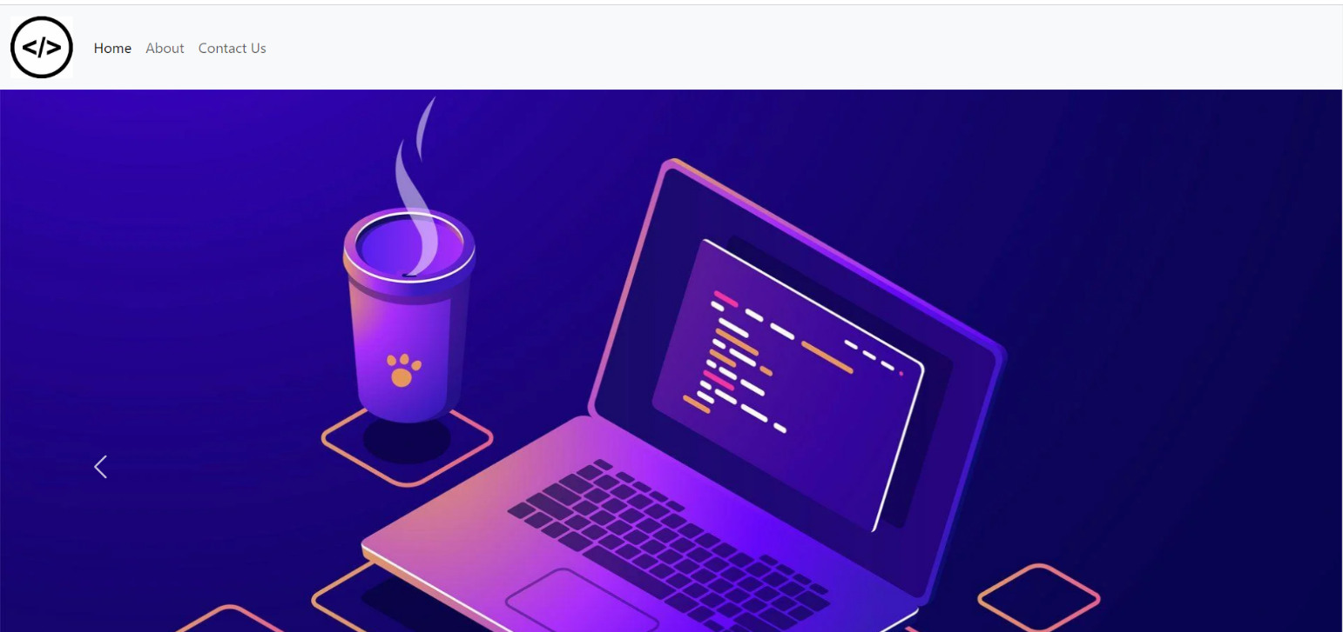

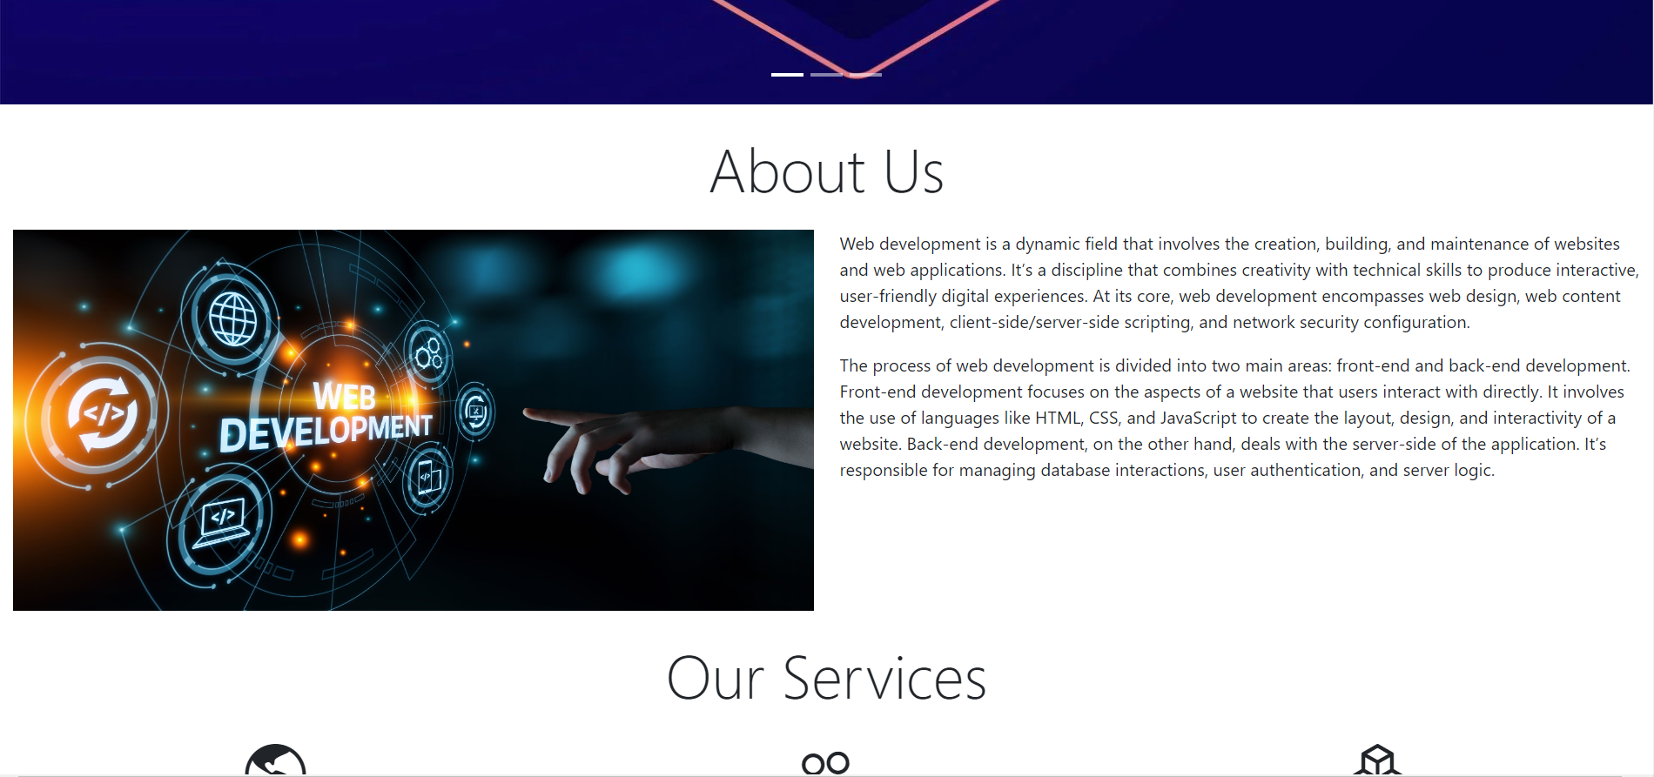

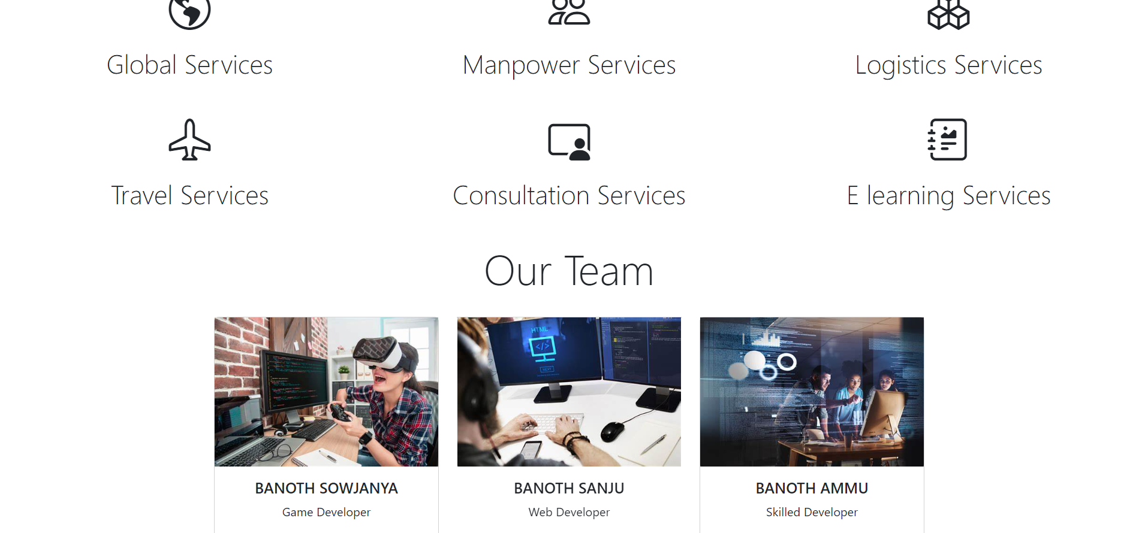

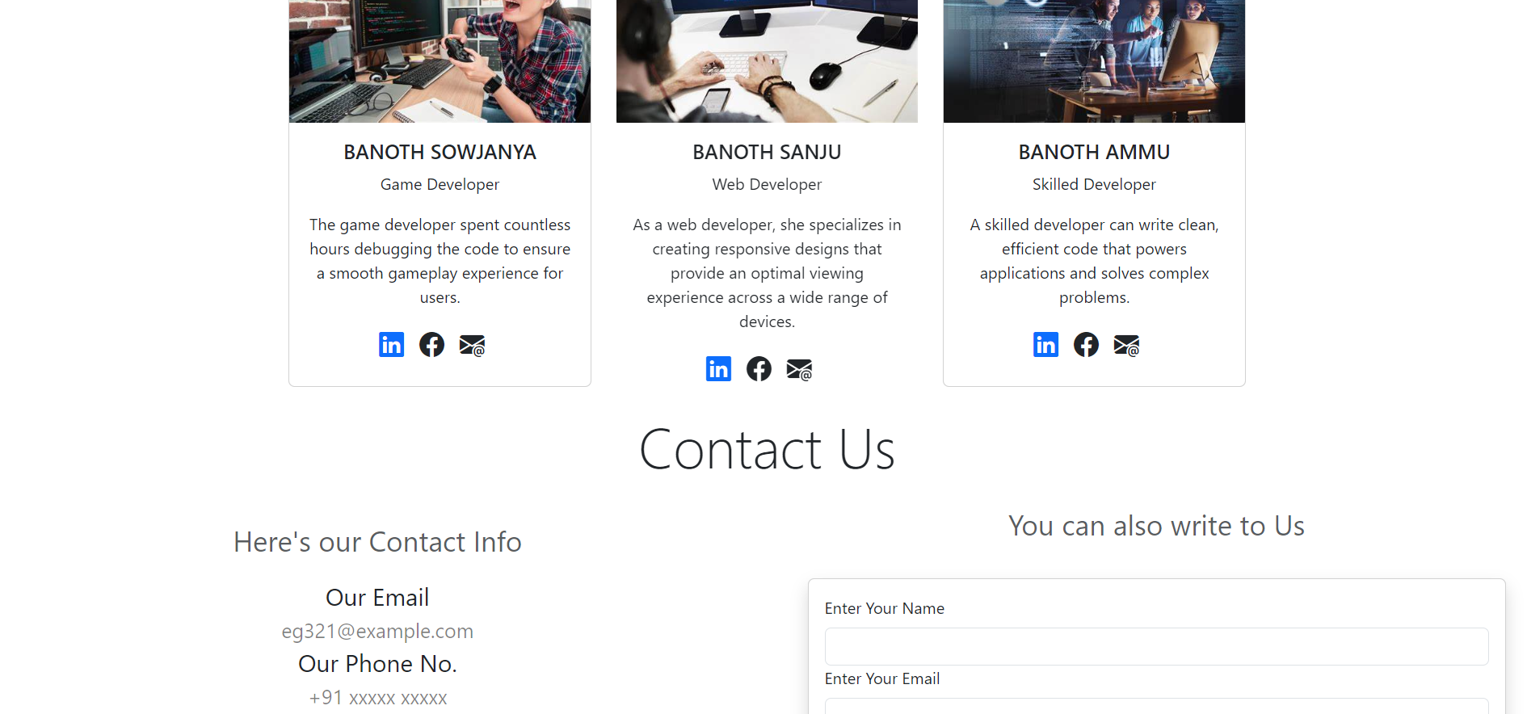

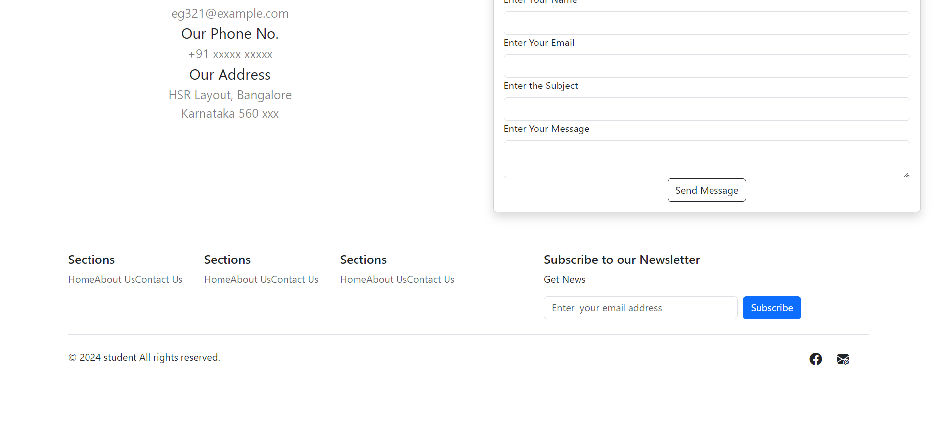

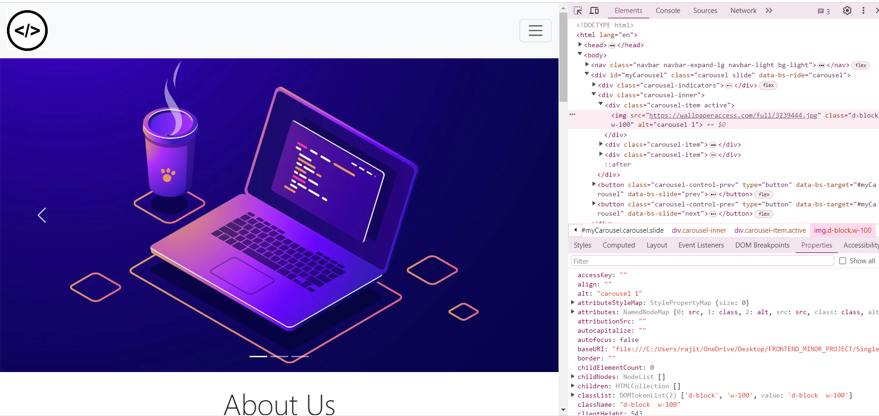

**Metadata and External Dependencies :** The “<head>” section contains metadata such as page title, description, keywords, author information, and viewport settings. It also includes links to external CSS frameworks like Bootstrap and font libraries like Font Awesome and Bootstrap Icons.

**Navigation Bar :** The “<nav>” element represents the navigation bar of the website. It contains links to different sections of the page, including Home, About, and Contact Us.

**Carousel :** The “<div id="myCarousel" class="carousel slide">” section creates a carousel/slider with images. Users can navigate through different slides by clicking on the previous and next buttons.

**About Us Section :** This section provides information about web development, including its definition, core concepts, and the division between front-end and back-end development.

**Our Services Section :** It showcases various services offered by the website, represented by icons and brief descriptions.

**Our Team Section :** Displays profiles of team members involved in the project, including their names, roles, descriptions, and social media links.

**Contact Us Section :** Offers contact information such as email, phone number, and address, along with a form for users to submit messages.

**Footer :** The footer contains additional navigation links, a newsletter subscription form, and social media icons.

**External Scripts :** Lastly, the code includes links to external JavaScript libraries like jQuery and Bootstrap JavaScript files for enhancing interactivity and functionality.

**CONCLUSION :**

In conclusion, the creation of this single-page website represents a pivotal step towards democratizing access to web development education and fostering a culture of innovation and inclusivity in the digital landscape. By bridging the chasm between theoretical concepts and hands-on application, our platform endeavors to empower individuals from diverse backgrounds to realize their full potential and embark on their journey in web development with unwavering confidence.

As we strive to cultivate a community of lifelong learners, our commitment to excellence remains unwavering. Through rigorous analysis of user feedback and continuous iteration, we pledge to evolve and adapt our platform to meet the ever-changing demands of the digital era. From refining existing content to introducing novel features and technologies, our relentless pursuit of improvement underscores our dedication to providing an unparalleled learning experience.

Furthermore, we recognize the transformative power of collaboration and are committed to forging partnerships with industry leaders, educational institutions, and tech communities to amplify the impact of our platform and foster a thriving ecosystem of innovation and creativity. Together, we aspire to reshape the landscape of web development education, transcending boundaries and empowering individuals worldwide to chart their path towards success in this dynamic and exhilarating field.

In essence, our journey does not culminate with the launch of this website; rather, it signifies the dawn of a new era in web development education—a journey marked by innovation, inclusivity, and endless possibilities. As we embark on this adventure together, we invite individuals from all walks of life to join us in shaping the future of technology and redefining the boundaries of what's possible in the digital age.